Project Title
Smart Organ Donation Matching System using Search Algorithms
Problem Description
This project focuses on solving an organ donor-recipient matching problem using search techniques. The system considers multiple constraints such as blood group compatibility, organ type, urgency level, and geographical distance.
The objective is to model this real-world problem as a search problem and identify an optimal match efficiently.
Motivation / Use Case
Organ allocation is a critical decision-making problem where time and accuracy are important. A systematic search-based approach can help in:
- Reducing matching time
- Improving allocation efficiency
- Handling multiple constraints simultaneously
Problem Formulation
- State Space: Each state represents a donor-recipient pair: (Di, Rj)

- Actions:
• Select a donor node
• Expand possible recipient nodes
• Evaluate compatibility constraints
- Transition Model: Transition occurs by moving from one donor-recipient pair to another based available combinations and constraint satisfaction.

- Goal Test:
A state satisfies the goal if:
Blood group compatibility is valid ,Organ type matches ,Recipient urgency is considered

- Cost Function:
The cost function is defined based on:

- Distance between donor and recipient
- Time required for transplantation
- Degree of compatibility
Total cost = f(distance, time, compatibility)
Technical Plan
Algorithms to be Implemented
- Breadth First Search (BFS) → for exhaustive exploration
- Uniform Cost Search (UCS) → for optimal cost-based selection
- A* Search Algorithm → for informed and efficient search
Proposed Heuristic
A heuristic function h(n) is defined to estimate the cost of reaching an optimal match:
h(n) = compatibility score + distance factor + urgency factor
Where:
- Compatibility score penalizes mismatches
- Distance factor accounts for location
- Urgency factor prioritizes critical patients

Justification:

The heuristic is admissible as it does not overestimate the actual cost and helps in guiding the A* search efficiently.
It is also consistent, ensuring optimality.

Block Diagram / System Flow
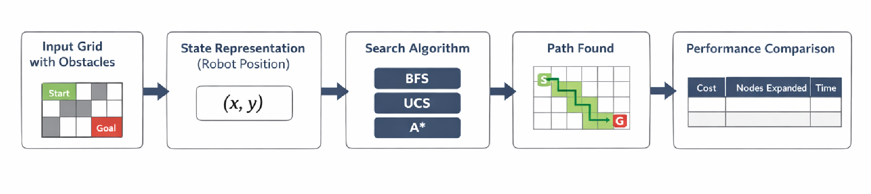
Tools & Technologies
- Programming Language: Python
- Data Structures: Lists, Priority Queue
Expected Output / Results
- Identification of optimal donor-recipient pair
- Performance comparison based on:
- Path cost
- Nodes expanded
- Execution time
- Observation: A* should give faster and more optimal results compared to BFS and UCS.

What NOT to Do (Common Mistakes)
- Using search algorithms without explaining their role in the problem
- Giving unclear or random block diagrams without logical flow
- Mentioning unnecessary tools or libraries that are not actually used
- Copying standard problems without adapting them to the chosen scenario
- Not properly defining state space, actions, transition model, and cost function
What a Good Proposal Shows
- Clear problem formulation with proper definition of:
- State space
- Actions
- Cost function
- Logical connection between:
Problem → Algorithm → Output
- Justification of algorithm and heuristic selection
- Simple and structured system flow

GROUP MEMBERS

- R VIDYA SHREE (ENG24AM0069)
- VAISHANAVI (ENG24AM0109)
- POLIREDDY THRISHA REDDY (ENG24AM0246)
- VOOKA SRAVANI(ENG24AM0317)

